1. Identify 3 Companies
   1. OnePlus
      1. [www.oneplus.com](http://www.oneplus.com)
      2. 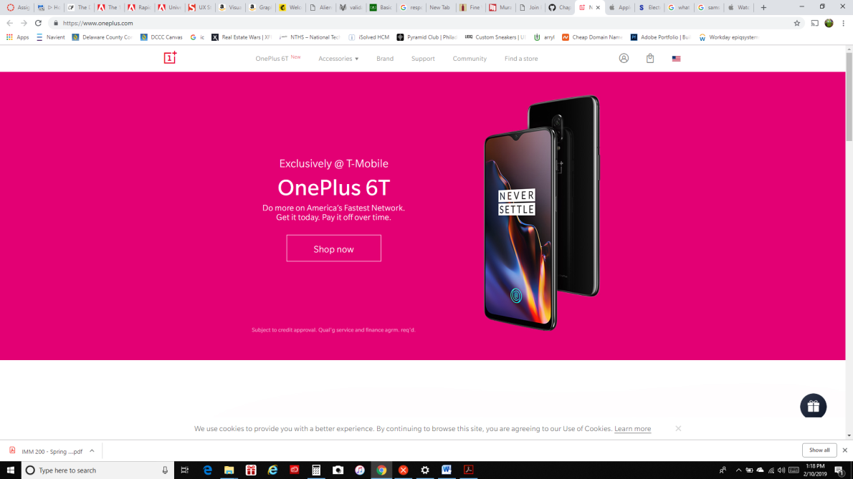Only OnePlus website is a direct competitor to Apple and Samsung since both of them are in the mobile phone business. OnePlus only sell mobile phones as they main stream of income. OnePlus main focus is to sell phone which is in the center of the home page with a buy now button with no price. This will encourage potential buyers to order a phone without being discouraged by the price.
   2. Apple
      1. [www.apple.com](http://www.apple.com)
      2. 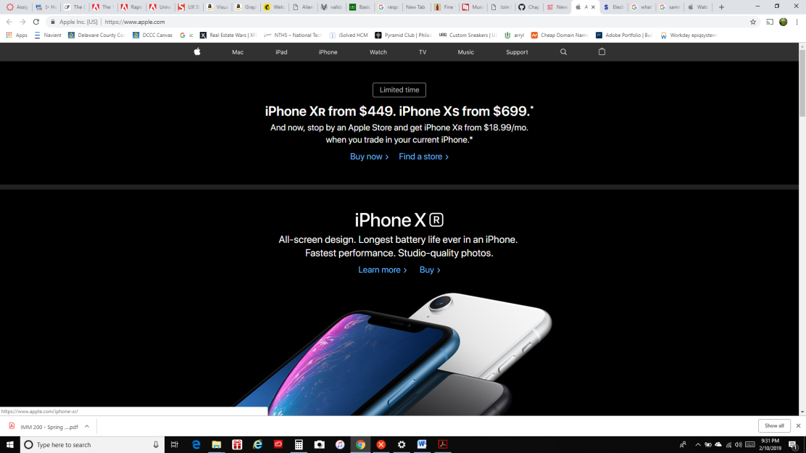Although, Apple INC are also in the mobile phone business they cater to a much larger audience but selling more hen just mobile phones such as computer hardware, audio hardware, wearable hardware, and also streaming TV and music. Because of this reason, this made Apple in indirect competitor to OnePlus but not Samsung. Phones are they main profit so they are place in the center of the site and it is hard to missed them.
   3. Samsung
      1. [www.samsung.com](http://www.samsung.com)
      2. 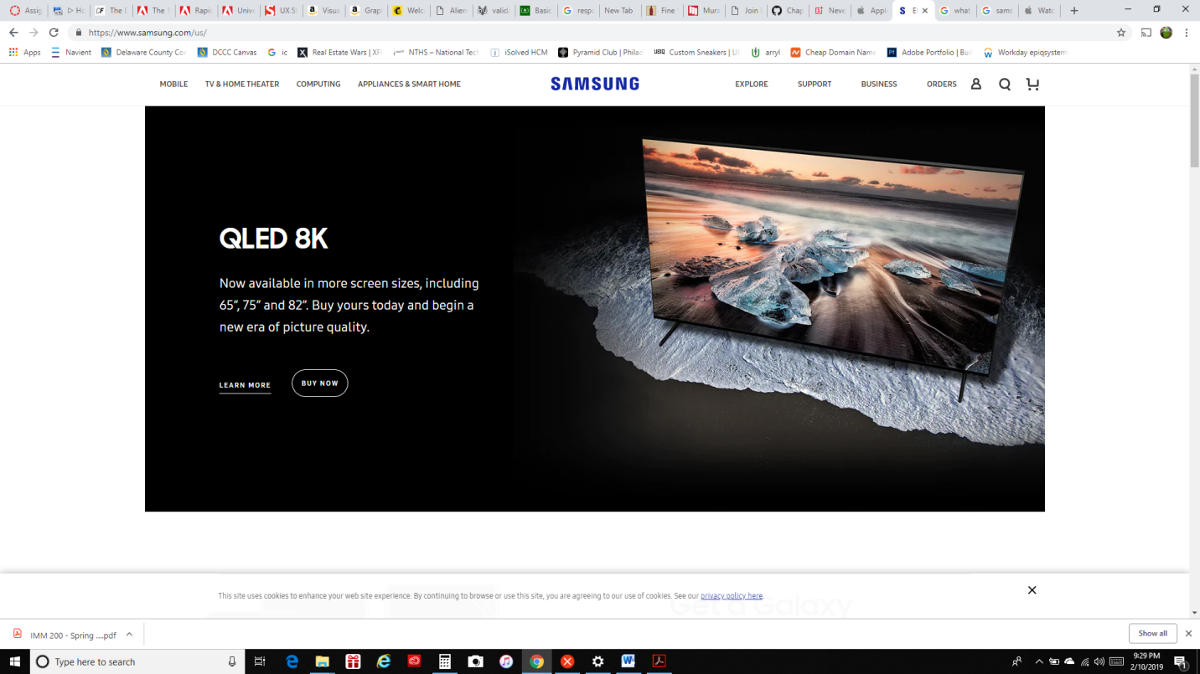Just like Apple, Samsung sell more than just a mobile phone so this will make them an indirect competitor as a company to OnePlus but direct competitor to Apple since they sell similar tech. Samsung site to carting to all of it customer not just mobile phone users. Therefore, you will see a lot of different product on their page.
2. Content and navigetion

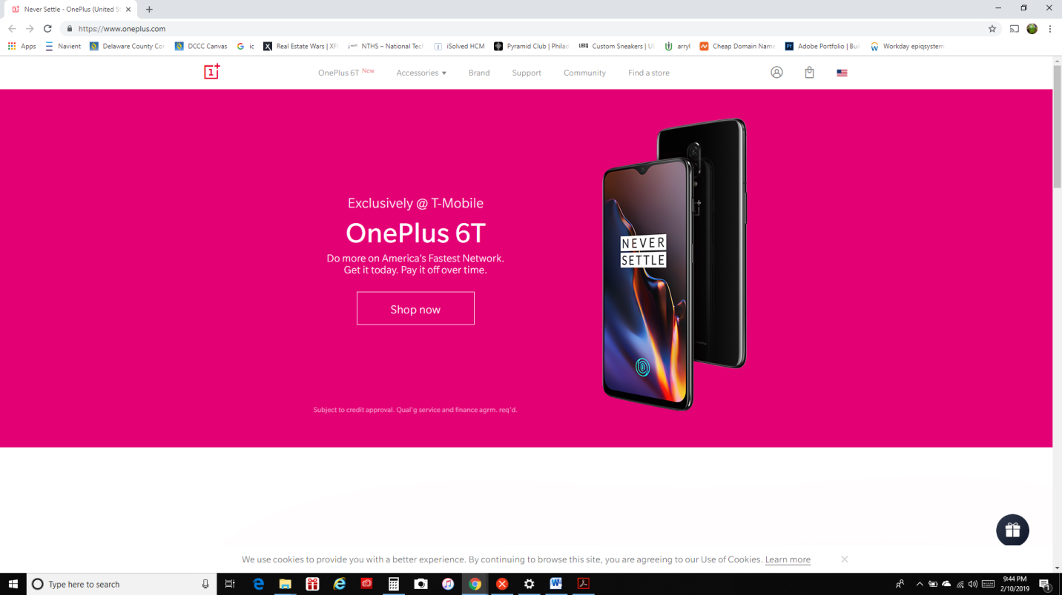

OnePlus.com

This menu is very simply and easy to use no matter the level of the user. They are not too many choice to pick from, around no more than seven. Starting from the left to right , the word are large and bold enough to stand out from the user. The first choice is the phone itself because they are trying to push the customer to buy this phone and it will be hassle free. Next to the phone menu, the drop down menu for the accessories which is another way for the money to gain some profit.

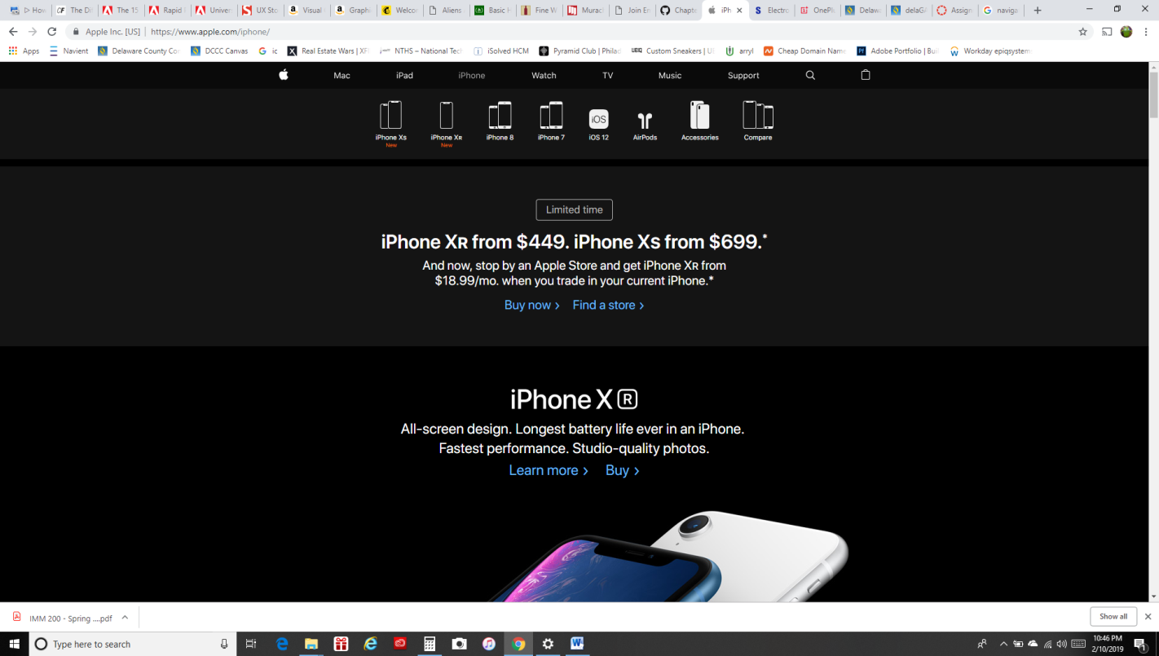Apple.com

Apple navigation menu work well with the white text and dark grey background color. Also, right under the menu are the thumbnail photos of the mobile phone which is apple big seller for profit. Apple pride themselves as simple and clean lines when it come to their product, and apple took that same style to their website.

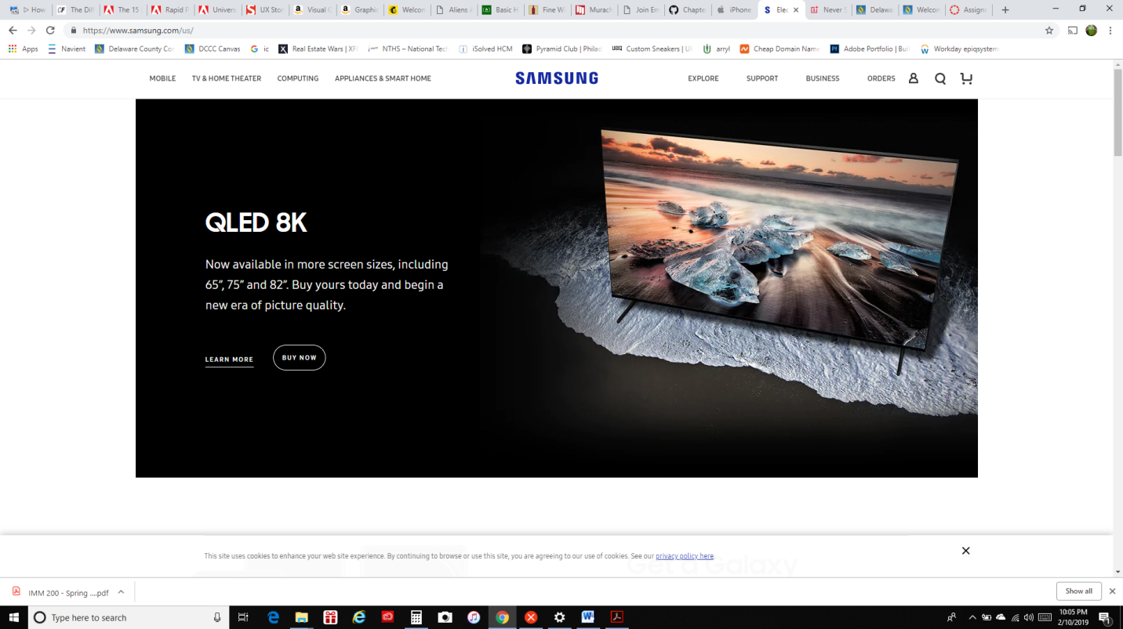Samsung.com

Unlike OnePlus and Apple , Samsung is putting all the items that they are selling in the navigation menu such as mobile, Tv & Home Theater, Computer, and Home appliances just to name a few. They seem like they want their customer to have an option to look at all what they are selling. For example, you may come to this site to buy a phone but you notice that you needed a new TV. After the phone, you select the TV menu to buy. If you are a fan of the brand you may want to but everything with the Samsung name on it. This method is not a bad idea to have all the Samsung product, phones or not next to each other to sell.

In my opinion, the Best to worst menu will have to be OnePlus, Apple, and Samsung. OnePlus is very easy to use with not a lot of information force on to you as Samsung which is the worst. Because Samsung force too much information in your face, they give you too many opinions to pick from. You cannot make all user happy since some will look at it as too much info. and other are pleased with the info. Apple site design is very clean with all the product in the center of the screen making the user focus on that area since that is the first spot the humans eyes are draw to.

1. 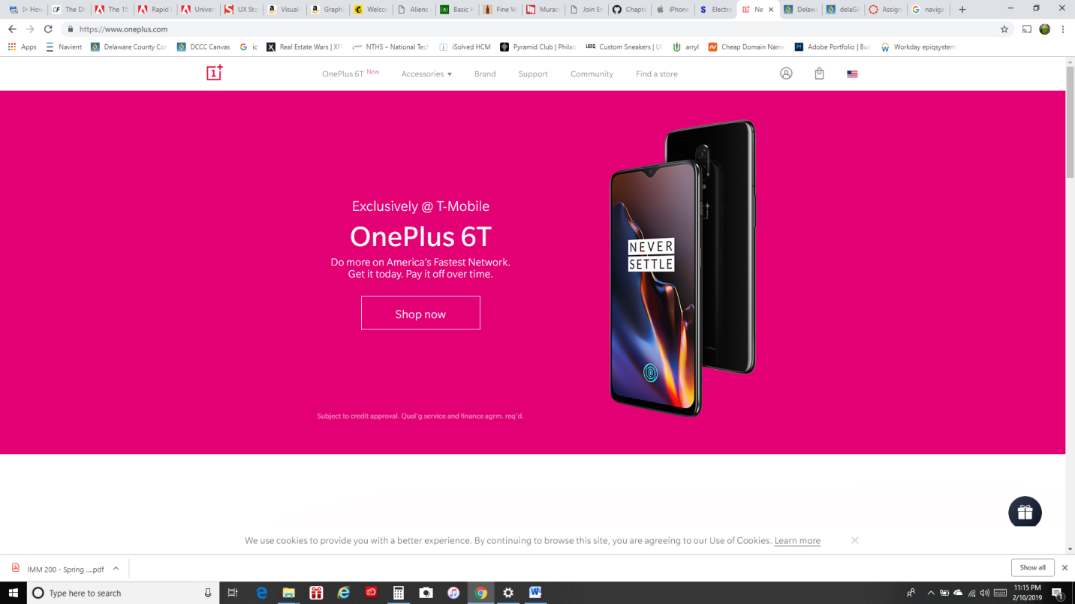Aesthetics and style

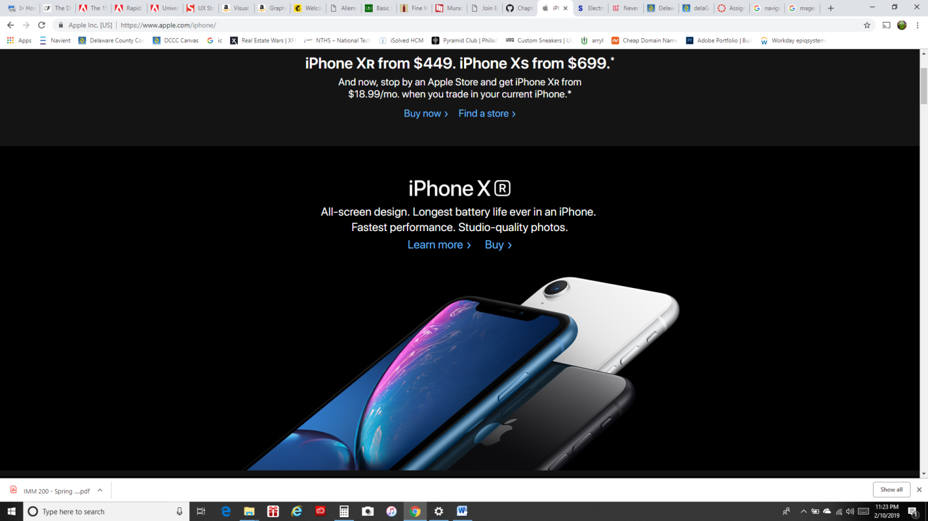OnePlus color brand are white and red but since OnePlus had team up with T-Mobile, the website color are matching T-Mobile to promote the partnership. T-Mobile color are magenta. With the magenta T-Mobile color in the center of the screen and the OnePlus phone also in the center is showing that they had truly team up.

Apple

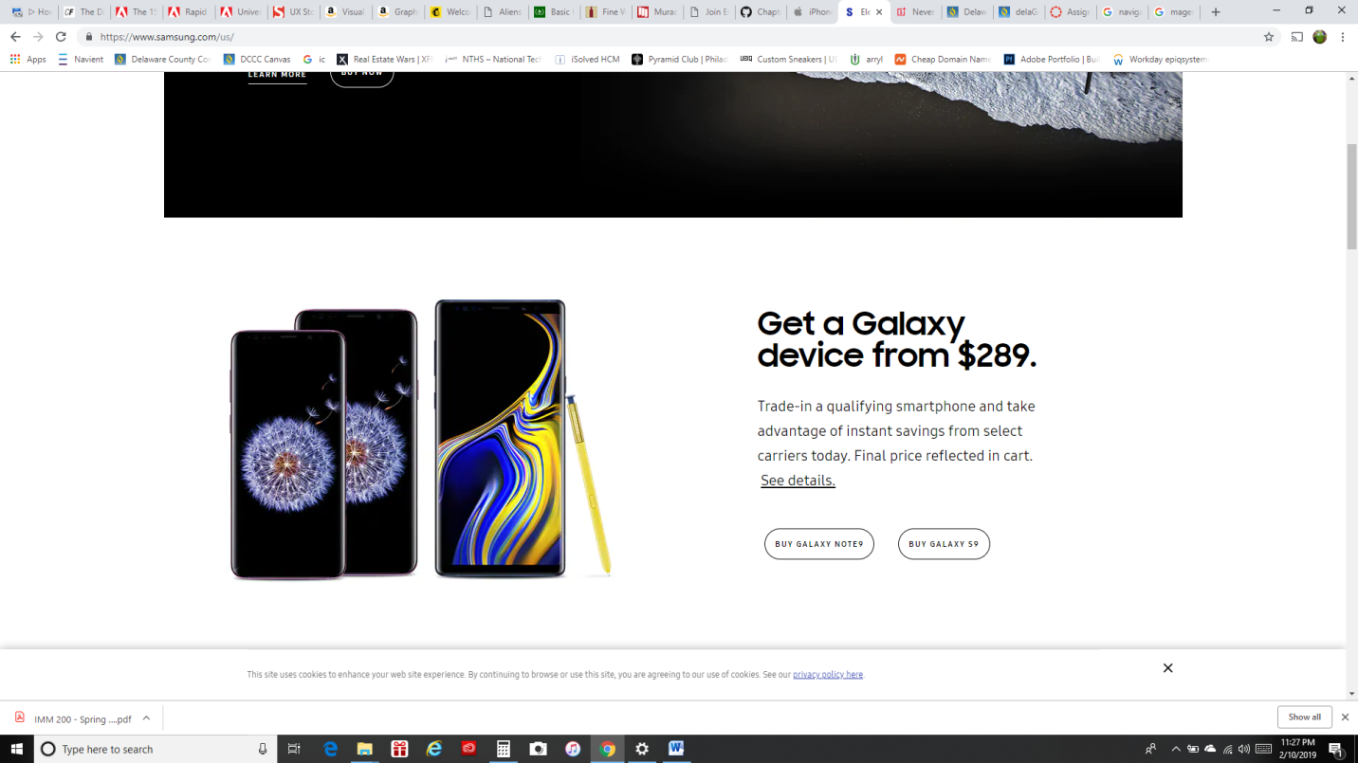Apple is showing off their best phone with high quality photos with the price next to them. Some customer might say the price is too high. But, next to the price you have the option to pay for the photos in monthly payment is will attract a lot people to buy.

Samsung:

Samsung also using high quality photos of their phone to bring in buyer. Also, having the price next to the phone with the font saying “Trade-in a qualifying” will attract more customers. Samsung do not stick to one type branding color other than black from the mobile device department.

Heuristic Analysis

**User control and freedom**

## Match between system and the real world.

## Help users recognize, diagnose, and recover from errors

OnePlus Pride them self as a young company who listen to the customer. With the User can have total control and freedom to do what you want on the phone since most of the other company got their phone locked so you cannot change the function of the operating system (O.S). Apple and Samsung do not want the user to change any about the OS nor hacked it in any way. But, OnePlus welcome user to do this to customize the phone to their needs. If anything were to happen this company give you the option to reset the phone back to the factory setting. These phones are built with today world in mind

with the large screen to do more work or watch movies. Large volume button to better the control the audio.

**UI animations**

The UI animations are very similar to one another. They are nothing fancy but the just drop down menu, an new menu appear when you hove over a picture which can give the user a preview which selecting that category.

|  |  |  |  |
| --- | --- | --- | --- |
|  | OnePlus | Apple | Samsung |
| Content & Navigation | 4 | 4 | 3 |
| Aesthetics & style | 4 | 8 | 7 |
| Heuristic Analysis | 3 | 5 | 6 |
| UI Animation | 2 | 2 | 3 |
|  | 3.2 | 4.7 | 4.7 |